**Module: R1: C Programming**

**Section:** Build Systems **Task:** Make or Break

**Task 4.1**

**Make or Break**

1. **Code Snippets:**
   1. **header.h:**

#ifndef HEADER_H

#define HEADER_H

#include<stdio.h>

//Function Prototype

int add(int *x, int *y);

#endif

* 1. **main.c:**

#include<stdio.h>

#include "header.h"

int main(){

int x,y;

int sum = 0;

printf("Enter the value of x: \n");

scanf("%d", &x);

printf("Enter the value of y: \n");

scanf("%d", &y);

sum = add (&x, &y);

printf("Sum is = %d\n", sum);

return 0;

}

* 1. **other.c:**

#include "header.h"

int add(int *x, int *y){

int sum=0;

sum = *x + *y;

return sum;

}

1. **Key Visualization:**

make build

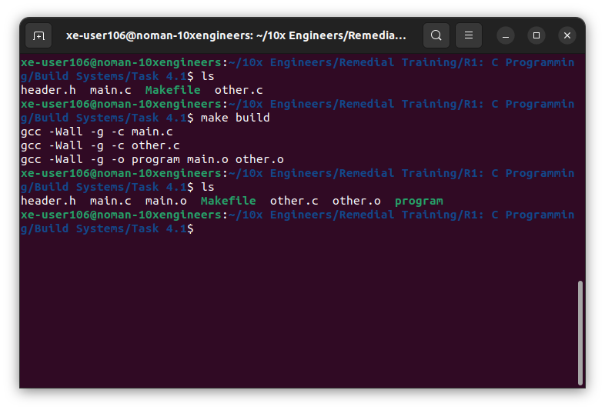

1. **Output:**

